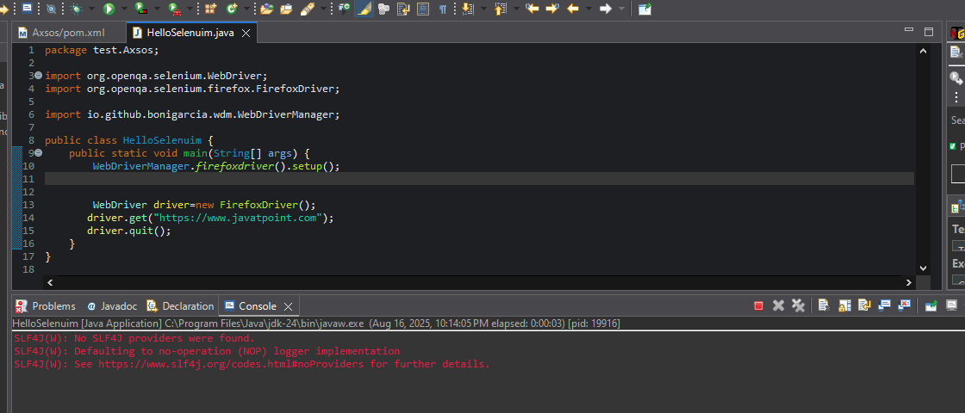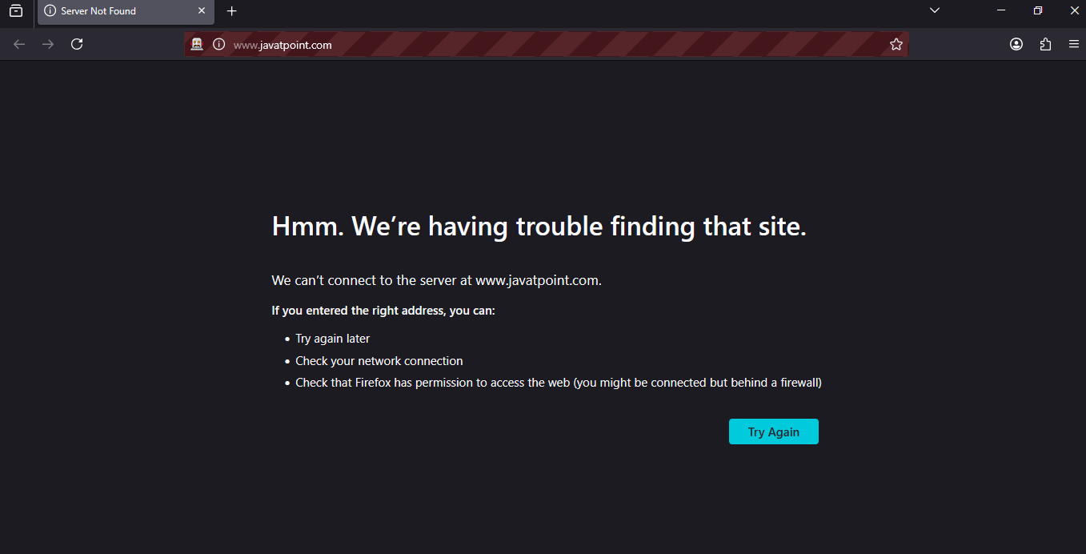

package test.Axsos;

import org.openqa.selenium.WebDriver;

import org.openqa.selenium.firefox.FirefoxDriver;

import io.github.bonigarcia.wdm.WebDriverManager;

public class HelloSelenuim {

public static void main(String[] args) {

WebDriverManager.*firefoxdriver*().setup();

WebDriver driver=new FirefoxDriver();

driver.get("https://www.javatpoint.com");

driver.quit();

}

}

<project xmlns="http://maven.apache.org/POM/4.0.0" xmlns:xsi="http://www.w3.org/2001/XMLSchema-instance"

xsi:schemaLocation="http://maven.apache.org/POM/4.0.0 http://maven.apache.org/xsd/maven-4.0.0.xsd">

<modelVersion>4.0.0</modelVersion>

<groupId>QA</groupId>

<artifactId>Axsos</artifactId>

<version>0.0.1-SNAPSHOT</version>

<packaging>jar</packaging>

<name>Axsos</name>

<url>http://maven.apache.org</url>

<properties>

<project.build.sourceEncoding>UTF-8</project.build.sourceEncoding>

</properties>

<dependencies>

<dependency>

<groupId>junit</groupId>

<artifactId>junit</artifactId>

<version>3.8.1</version>

<scope>test</scope>

</dependency>

<!-- https://mvnrepository.com/artifact/org.seleniumhq.selenium/selenium-java -->

<dependency>

<groupId>org.seleniumhq.selenium</groupId>

<artifactId>selenium-java</artifactId>

<version>4.20.0</version>

</dependency>

<!-- https://mvnrepository.com/artifact/io.github.bonigarcia/webdrivermanager -->

<dependency>

<groupId>io.github.bonigarcia</groupId>

<artifactId>webdrivermanager</artifactId>

<version>6.2.0</version>

</dependency>

</dependencies>

</project>